Name: | Aaryan Urunkar
UID: | 2023800131
Experiment No. | 5

AIM: | To understand different types of inheritance.
Program 1
PROBLEM STATEMENT : | Let's assume you work in a software company. And your manager told you about a project to find out the volume of a box. You, the competent employee, completed this task by creating a simple Box class.The next day, he told you to rewrite the program, adding weight as well. But, you had clear inheritance concepts, so you have created a child class, BoxWeight, and inherited the Box class.But, the manager was not impressed and told you again to rewrite the code and add Shipment details. This made you a little disturbed, but then you recalled your multilevel inheritance concept. You created another class, Shipment, and inherited the BoxWeight class.
PROGRAM: | class Box{ //Creating base class  int length, breadth, height;  double calcVolume(){  return length*breadth*height;  }  }  public class BoxWeight extends Box{ //Creating child class  int weight;  void setWeight(int weight){  this.weight = weight;  }  }  import java.util.Scanner;  public class Shipment extends BoxWeight { //Creating multilevel child class  Scanner sc=new Scanner(System.in);  Scanner sc1=new Scanner(System.in);  String date;  int price;  void addShipmentDetails(){  System.out.println("Enter shipment due date in DD/MM/YYYY form: ");  date = sc.nextLine();  System.out.println("Enter shipment price:");  price= sc1.nextInt();  }  }
RESULT:

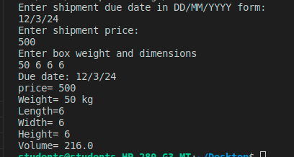

Program 2
PROBLEM STATEMENT : | Employee salary –Basic sal -5000  Permanent employe increment – Basic sal *10%  Temporary employee increment-Basic sal*5%
PROGRAM: | public class Employee {  int basic_sal;  Employee(){  basic_sal = 5000;  }  }  public class Increment extends Employee{  int incrementFactor;  Increment(int incrementFactor){  super();  this.incrementFactor = incrementFactor;  }  void calcSalary(){  System.out.println("Salary of employee is: " + (super.basic_sal*(((double)incrementFactor/100) + 1)));  }  public static void main(String[] args) {  Increment ob;  Scanner sc=new Scanner(System.in);  System.out.println("Enter 1 if employee is permanent and 0 if employee is temporary: ");  int ch = sc.nextInt();  if(ch==1){  ob=new Increment(10);  } else {  ob = new Increment(5);  }  ob.calcSalary();  }  }
RESULT:
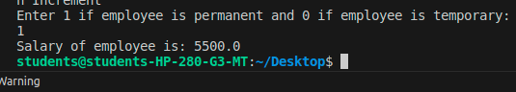

Program 3
PROBLEM STATEMENT: | Create a class called Animal with a method sound() that displays a generic sound. Then, create a subclass called Dog that inherits from Animal and overrides the sound() method to display "Woof". Create another subclass called Cat that inherits from Animal and overrides the sound() method to display "Meow". Finally, create a subclass called Cow that inherits from Animal and overrides the sound() method to display "Moo". In the main method, create objects of Dog, Cat, and Cow classes and call the sound() method for each object.
PROGRAM: | public class animal_main {  public static void main(String[] args) {  dog dog =new dog();  cat ob =new cat();  cow cow = new cow();  dog.sound();  ob.sound();  cow.sound();  }  }  class animal {  void sound(){  System.out.println("Roar!!!!!");  }  }  class cat extends animal{  void sound(){  System.out.println("Meow");  }  }  public class cow extends animal{  void sound(){  System.out.println("moo!");  }  }  class dog extends animal{  void sound(){  System.out.println("Woof");  }  }
RESULT:

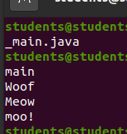

Program 4
PROBLEM STATEMENT: | he cost of stock on each day is given in an array A[] of size N.  Day 1 price in first location, day 2 price in second location etc. Find all the days on which you buy and sell the stock any number of time so that in between those days your profit is maximum.A new transaction can only start after previous transaction is complete. Person can hold only one share at a time.  Create class Stock that has name of stock and array of prices. Also it has input method that initialises the predicted price of the stock in an array of length N.  Create class Transaction that is sub class of Stock class. It has method findMaximumProfit method.  Example  Stock Prices: {1, 5, 2, 3, 7, 6, 4, 5}  Total profit earned is 10  Buy on day 1 and sell on day 2  Buy on day 3 and sell on day 5  Buy on day 7 and sell on day 8
PROGRAM: | public class Stock {  int[] stocks;  Stock(){  stocks = new int[]{1,5,2,3,7,6,4,5};  }  }  public class Transaction extends Stock{  int result(boolean holding, int index, int[] arr, int profit){  if(index >= arr.length){  return profit;  } else if(holding == true){  int released = result(false, index+1, arr, profit + arr[index]);  int retained = result(holding, index+1, arr, profit);  return released>retained?released: retained;  } else {  int buy = result(true, index+1, arr, profit - arr[index]);  int ignore = result(false,index+1,arr,profit);  return buy>ignore?buy:ignore;  }  }  public static void main(String[] args) {  Transaction ob = new Transaction();  int a =ob.result(false, 0, ob.stocks, 0);  System.out.println("Total profit earned is: " + a);  }  }
RESULT:

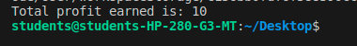

CONCLUSION: | I learnt inheritance concepts.

